The 6th Conference of African Ministers Responsible for Civil Registration
Addis Ababa, Ethiopia
24-28 October 2022
Exhibition Manual

Economic Commission for Africa
Conference of African Ministers Responsible for
Civil Registration
DATE: 24-28 October 2022
VENUE: Addis Ababa, Ethiopia

Exhibition Booth Package
Package includes:
- •Fascia Label (Stand sign).
- •Two complimentary identification badges.
- •Shell scheme of 6 sqm.
- •Spotlights.
- •Table and two chairs.
- •Counter cabinet.

Programme Outline:
20 October 2022
-1st Build up day
23 October 2022
-2nd Build up day
-Exhibitors’ stand dressing
-Final clean up
24 – 28 October 2022
-Exhibition on display (each day opens 9:00 a.m. and closes 6:00 p.m.)
29 October 2022:
-8:30 a.m. to 1:00 p.m. - Stand clearing by exhibitors
-2:00 p.m. onwards - Exhibition break down
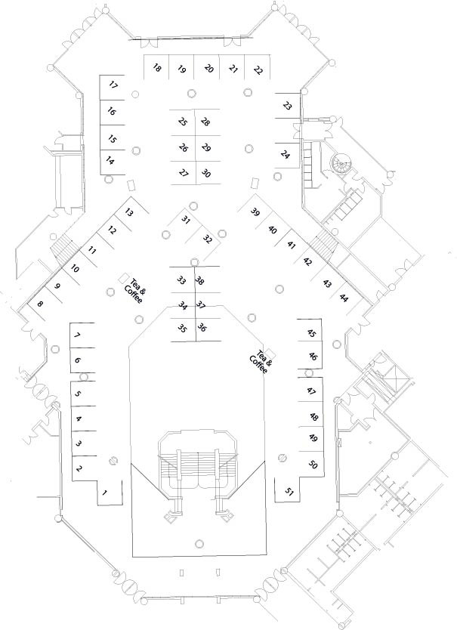
1. Indemnity
The Economic Commission for Africa (ECA) will not be held responsible by the authorities in Ethiopia for the payment of any customs levy, tax, ﬁne or other costs incurred by an Exhibitor. In any event, the Exhibitor must undertake to indemnify the ECA from and against any payment which ECA may be called upon to make to the authorities on their behalf. Please read and sign the indemnity section of the Registration Form.

2. Access to the Exhibition area
2.1 Badges
Exhibitors (and co-exhibitors/staff) are required to wear ID Badges at all times in order to gain access to the Exhibition area. These will be issued by the organizers during build-up (See Programme). Please complete personal details on the Exhibitors Registration Form.
2.2 Vehicle Pass
Vehicles without proper permits may not be allowed to the Exhibition area. However, during build-up and breakdown, special vehicle passes will be issued. Please fill and return Form IV.
3. Your Exhibits
3.1 Shipping
All samples, brochures, posters, stand equipment, etc. may be imported into Ethiopia as exhibition material for re-exportation.
All exhibitors should make their own shipping arrangements through local clearing agents in Addis Ababa if necessary.
3.2 Security
The organizer declines to take responsibility for any loss or damage which may occur, including responsibility for the security of a stand, its exhibits and contents as well as personal property. You are urged to take out your own independent insurance against loss. In our experience, cell phones, briefcases, cameras and handbags are most at risk. Please do not leave them on your stand.
4. Your Exhibition Stand
4.1 Stand Construction
- Floor Covering
The Exhibition ﬂoors are brown marble and un-carpeted.

- Floor Loading
The capacity is 500kg per sqm.
- Electricity Supply (per “Exhibition Manual” by a/m)

The operating voltage available is 220-230 volts.
Please note:
Extended size Stands are only available in multiples of standard booth size. Their positioning will be at the discretion of the organizers
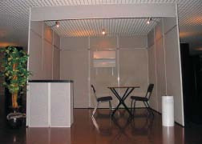
Standard 6 sqm Exhibition Shell Scheme (booth)
4.2 Stand Dressing
The shell scheme consists of grey partition walls and fascia board across the front and, where applicable, the sides (see sketch). Company name is supplied in standard lettered graphics (Complete Form 2). No logos or banners are permitted on the FASCIA boards. Each unit is ﬁtted with appropriate number of spotlights and electrical outlets and is supplied with 1 table, 2chairs, and 1 cabinet. Posters and pictures can be attached to the walls by means of Velcro hooks or Velcro tape. Under no circumstances may nails, glue or double sided tape be used on the Stand system. Any damage done will be charged to the exhibitor’s account.
4.3 Stand Safety and Security
The organizer reserves the right to remove any item considered dangerous (ﬂammables, explosives, weapons, etc.) from the exhibition area. Fire exits must not be blocked, and disused packaging materials must be removed to avoid safety hazards. All items must be placed within the Stand area. No item will be allowed which obstructs the ﬂow of people in the aisles and passageways.
4.4 Sale of Exhibits
Once the exhibition is open, no item may be set up, added or removed from Stands. No sale of exhibits/products from Stands is permitted, unless speciﬁcally requested and explicitly permitted (in writing) by the organizer in compliance with authorities.
4.5 Attendance at your Stand
Exhibitors are welcome to share the Stand with another organization as long as ECA has agreed thereto. However, only one organization’s name may be displayed on the fascia board. ECA reserves the right to have exhibits of any organization removed for which prior notiﬁcation of attendance has not been supplied. Please ensure that exhibition staff is in attendance at all times. The organizer will provide security staff to safeguard exhibits but declines any responsibility for loss or damage which may occur.

General Information
1. Immigration Requirements
1A. Visa
Participants must obtain a visa from the Ethiopian Embassy in their country or they can apply online. If there is no Ethiopian embassy in your country, please send your passport details before 10 October 2022 so that the organizers can arrange a visa on arrival/entry at Addis Ababa airport.

Please send the registration form with passport and ﬂight information to the ECA (e-mail: belayt@un.org ).
2. Health care requirements
Prior to entry, visitors to Ethiopia should be in possession of a valid inoculation certificate for yellow fever. Vaccination against cholera is also required for any person who has visited or transited a cholera-infected area within six days of arriving in the country.
The United Nations Health Care Centre (UNHCC), situated on the ground floor of the UN Conference Centre provides 24 hours medical services. Payments to medical services must be made in cash at the visitor’s cost. In case of medical or dental emergency, please call the reception desk at telephone numbers 011 544 5502, 011 544 3548, 011 544 3135.

1B. COVID-19 Requirements
- Any international traveler above the age of twelve coming through international airports of the country shall bring a certificate of negative PCR test done up to 72 hours or three days before departure or Antigen- RDT negative test up to 24 hours before arriving to Ethiopia.
- Notwithstanding the above, the traveler can enter the country without PCR or Antigen – RDT test certificate if he/she has a certificate of recovery from COVID-19 within 90 days or if he/she has completed the COVID-19 vaccine in full and provides evidence.
- Notwithstanding the provisions 1 and 2 above, if the traveler is a diplomat and fails to fulfill the requirements provided above, he/she shall be tested at the airport and enter the country. Whereas if the test result is positive or if he refuses for test, he/she shall self-isolate for 7 days.
- Any person who is coronavirus positive is prohibited from entering the country.
Note:
- The COVID-19 PCR test result certificate obtained/issued for travel to Ethiopia is not valid for return flights.
- “Full vaccination” means 2 weeks after taking of the single dose of Johnson and Johnson, and 2 doses for Astra Zeneca, Sinopharm, Sinovac, Moderna, and Pfizer.
- During the conference, organizers may conduct the COVID-19 RT as required for the meetings. The organizers will make arrangements for this test. However, attendees are advised to have authentic and valid health insurance, as if the results are positive, attendees will be responsible for additional care required for a positive case.
- Each rapid antigen test costs USD 10, payable by each participant at the start.
- Each PCR test costs USD 25, payable by each participant at entry.
- Participants testing positive for COVID-19 will be quarantined at … Hotel and will be charged USD 300 per day and the person will be responsible for payment. Therefore, participants are advised to have a valid health insurance.
- Participants who are on chronic medication are advised to bring an adequate supply of their chronic medications, as not all brands may be available in Addis Ababa.
- Other consultations and laboratory tests are all at the expense of the participants.
- Participants who cannot tolerate high altitude are advised not to attend the meeting.
More details can be found at https://www.dfa.ie/travel/travel-advice/a-z-list-of-countries/ethiopia/

5. Transport
For travel in Addis Ababa, use yellow taxis, which are metered. Blue taxis can also be used. Taxis are available 24 hours.
6. Registration and Identification Badges
Participants are required to register and obtain identification badges prior to opening of the meeting. Kindly also carry your invitation letter and personal identification for onsite accreditation. For identification and security reasons, identification badges should be worn by all participants, at all time during the conference and at official social functions.

7. Additional information
- Weather
It is a Mediterranean climate in the north and the east and semi-arid in the interior and south Sahara. Average temperatures in October are expected to be a high of 23°C and a low of 10°C. Rainfall is irregular and concentrated during the cold season (three quarters of the annual total).

- Voltage
220V single phase, up to 220/380 V.
- Currency
The local currency is the Ethiopian birr (in July 1 euro = 53.92 birr, 1 USD = 52.72 birr). VISA Card is accepted in most banks in Ethiopia. Ethiopian birr can be withdrawn from bank counters at the airport, in hotels, in banks, in the city or through ATMs.

There is a branch of Commercial Bank of Ethiopia in the ECA compound – located in Congo building. This Bank is open Monday – Friday, from 8:00 am to 12:45 pm and from 2:00 pm to 4:30 pm.

- Language
The official language is Amharic. The other most widely spoken language is English, with some French and Arabic.

- Local time
The local time: Greenwich Mean Time + 3 (GMT+3).

- Telecommunications
Country dialing code: +251
SIM cards can be bought at the Ethiopia Telecom in the city. Both SIM card and Mobile phone should be registered to Ethiopia Telecom prior to their functioning.

8. Guidelines for Personal Security and Safety of Participants
Personal security is an individual responsibility. Using common sense and being alert can reduce risks. The aim of this Security Bulletin is to provide conference participants, with the necessary personal security advice, making them aware of the existing security rules and regulations that apply in Addis Ababa.
The best way to be safe is to avoid trouble at all cost, rather than having to extricate yourself later. The United Nations Security and Safety service is always ready to serve all its clients. In this regard, the cooperation of all participants at this meeting would help us a great deal in ensuring the safety of your valuables and your personal security.
Do the following while you are in the ECA premises:
- Display your Conference Badges, on demand to an authorized person and wear it visibly.
- Do not leave bags and parcels unattended; this will be conﬁscated or destroyed.
- Display the vehicle passes issued.
- Do not bring unauthorized persons and children into the conference centre.
- Safeguard your valuable property.
- Check your documents and items before you leave conference halls and meeting rooms; and
- If you lose any valuable items within the premises, inform UN Security and Safety Service, or
- Inform the nearest Security Ofﬁcer.

When you are in a Hotel:
- Upon entering or leaving your room, make it a habit to lock the door.
- Before leaving, inspect your room to make sure no money, jewelry, cameras, etc. have been left exposed.
- Deposit valuables or portable items at the reception desk and obtain a receipt.
- Do not open packages delivered to you unless you are expecting them; and
- Should you observe anything suspicious or out of the ordinary, please contact Security Service.

For information regarding substantive issues of the Conference, please contact:
Meaza Bekele  Statistician  African Centre for Statistics  Economic Commission for Africa  Tel: (251) -  E-mail: bekele21@un.org | Gloria Mathenge.  Statistician,  African Centre for Statistics  Economic Commission for Africa  Tel: (254) 704 37 76 51  E-mail: gloria.mathenge@un.org

For issues pertaining to your Exhibition, please contact:
Mr. Tesfaye Belay
African Centre for Statistics
Economic Commission for Africa
P.O.Box 3001
Addis Ababa, Ethiopia
Tel: +251 115 44 34 61
E-mail: belayt@un.org
Form I
Conference of African Ministers Responsible for
Civil Registration
24-28 October 2022, Addis Ababa, Ethiopia
United Nations Economic Commission for Africa
Exhibitor Registration Form
Deadline: September 25, 2022
Please Print
Exhibitor (Organization/ Company): _________________________________________
Exhibit (Type): __________________________________________________
Stand Number requested:
1st Option: ____________ 2nd Option: ____________ Multiple: ____________
If you require a larger stand, please indicate how many Stand modules you wish to merge.
Stand numbers are allocated on first come first served basis. ECA will allocate the next available stand number if your two choices are already taken.
Principal/ Organization's Contact Person (Director/ Proprietor)
First Name: __________________________ Family name: _________________
Position: ___________________________________________
Organization: _______________________________________
Address: __________________________________________
City: ______________________________________________
Country: ___________________________________________
Telephone: __________________________ Fax: ________________________
(Country City Local) (Country City Local )
E-mail: ____________________________________ Persons in Attendance Names:___________________________________

Multiple Stand Occupancy
List the names and addresses of other organizations you may be representing at your booth (maximum 2) (Subject to approval)
I hereby indemnify ECA and/or its agents against any and all costs that may be incurred on our behalf during the exhibition.
Name of Company/ Organization ---------------------------------------------------------------
Date: ________________________ Signature: __________________________
Director/Principal
Please send this registration form by email to belayt@un.org or fax it to: 251-11-5510389 attn: Mr. Tesfaye Belay

Form II
Conference of African Ministers Responsible for
Civil Registration
24-28 October 2022, Addis Ababa, Ethiopia
United Nations Economic Commission for Africa
Exhibition Stand Services Request
Deadline: September 25, 2022
Stand Number:______________
(As confirmed)
Organization: ____________________________________________________
First Name: _______________________ Last Name: _____________________
Telephone: ___________________________ Fax: ______________________
(Country City Local) (Country City Local)
E-mail: ____________________________________________________
Fascia Name
Exhibition stands will be provided with name labels on their fascia boards. These are for identification only and names should be abbreviated. All fascia labels will have uniform lettering; only one organization's name is permitted per stand. Please enter in the space below the name you wish to appear on your board, in capital letters.
Name to appear on name board (maximum 20 characters)
Name:________________________________________Date:_______________ Director or Principal of Exhibitor/ Organization

Form III
Conference of African Ministers Responsible for
Civil Registration
24-28 October 2022, Addis Ababa, Ethiopia
United Nations Economic Commission for Africa
Exhibition Shipping Request
Deadline: September 25, 2022
Please complete the form and Send to: Email: belayt@un.org or Fax: 251 115 51 0389 Attn: Mr. Tesfaye Belay
Name of Exhibitor: _________________________________________________ Address: _________________________________________________________
Telephone: __________________________ Fax: _________________________
E-mail: ______________________________________
Shipping
List goods you will be shipping or bringing as accompanied baggage. In the case of radios and electronic equipment, include make and serial number. Be sure to attach hereto the documents mentioned on page 4 of the Exhibition manual. Clearing Agents and Transportation costs will be charged to the Exhibitor's account. Non-UN organizations and companies will be provided a list of agents to contact in Addis Ababa.
Box No. | Contents | Quantity | Make | Serial No.

Form IV
Conference of African Ministers Responsible for
Civil Registration
24-28 October 2022, Addis Ababa, Ethiopia
United Nations Economic Commission for Africa
Vehicle Pass Request
Deadline: September 25, 2022
Please complete the form and Send to: Email: belayt@un.org or Fax: 251 115 51 0389 Attn: Mr. Tesfaye Belay
Name of Exhibitor: _________________________________________________ Address: _________________________________________________________
Telephone: __________________________ Fax: ______________________
E-mail: ______________________________________
Complete to apply (maximum 2)
Make | Color | Registration No. | Driver's Name

